Profit Calculation (Asset )

**Progress summary**-

* We are very happy with the progress of the site so far but we would like to work with you to further advance this website.
* We like the presentation of the page so far, but there are a couple of small errors.
* Basically this app allows us to track the progress of each job in regards to payment.
* This allows us to visualise the quotes received from each trade and in turn produces a running total of each of the costs in correspondence to the job.
* Therefore, we need these figures to be able to change with each entry.
* There are examples of this in the excel spread sheets which correspond to this document
* Included in this document are some changes and new ideas that we would like to be added to the app

**‘Add Task’ button-**

* We like the ‘add task’ page
* We need to change the ‘Client Charged’ option to ‘Expense incurred’

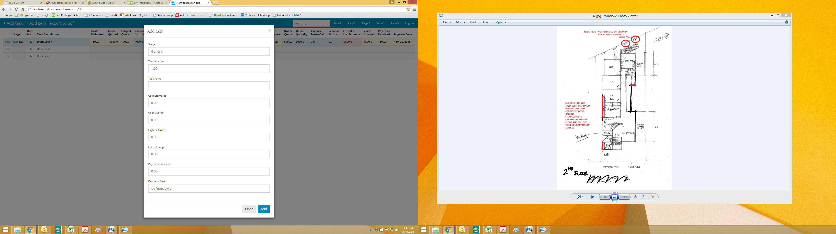

* This added task should also appear under the trade in which the task corresponds to on the home page
* This allows us to see all payments for each trade.
* All these payments should be visible while the tradesman are still completing the job. This is called job ‘open’
* Once the job is ‘closed’ (as seen below) then a summary of all the tabs such as ‘infront cost estimate’ ‘Client charge’, ‘Payment receive’ etc. Should be seen.

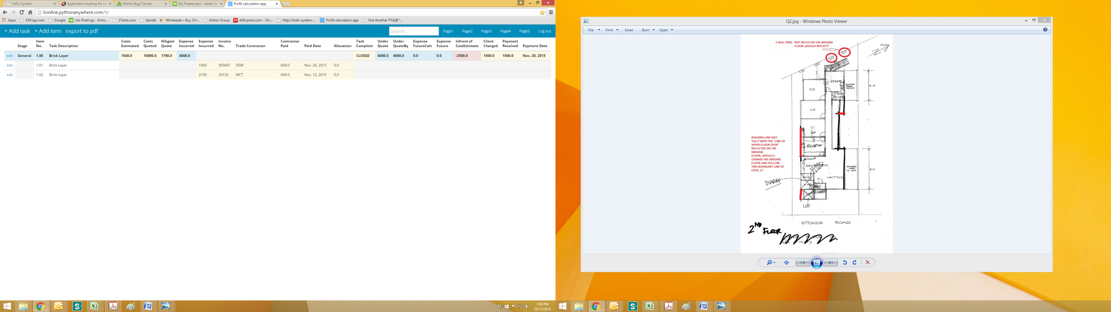

* This allows a final amount to be visulaised without all payments being seen.
* These payments for the ‘closed’ trades should only be seen when the trade is clicked on.
* Eg.

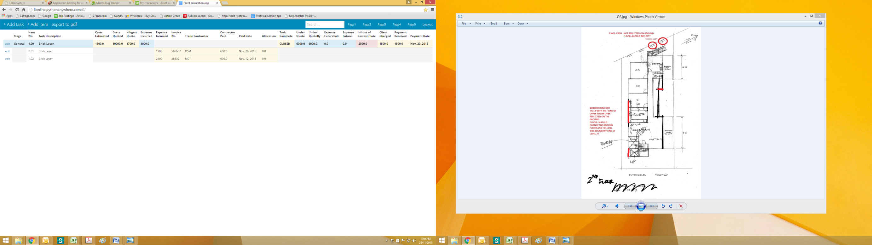

**In front of Cost estimate-**

* When a job is ‘open’ meaning the trades man are still working on this job we do not wish to see a money figure in the ‘Infront of cost estimate’ column

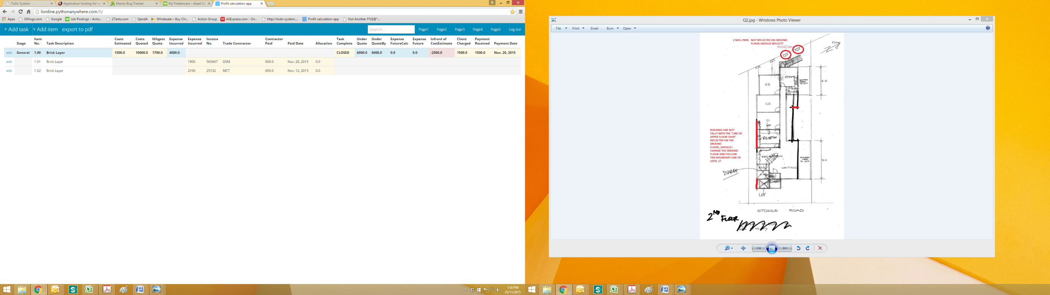

* This figure should remain as ‘0.00’ until the job is ‘CLOSED’



* This ensures that the figure is accurate and final!!

**Homepage-**

* When you open a particular job we would like this summary to appear as the first page

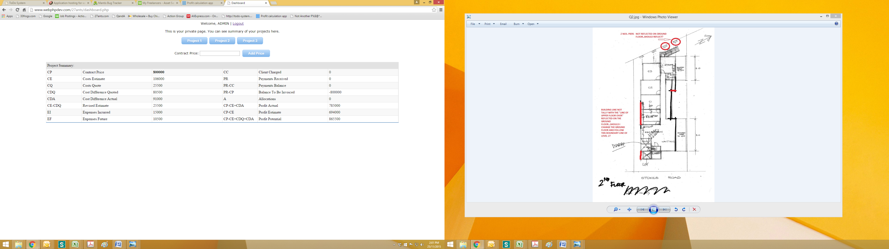

* These figures will change as the job progresses but it gives us a summary of the progress of the job at that point in time

**Overall design-**

* Attached to this email is a excel document titled **‘3 Units SPREADSHEET 1’**
* This gives you an example of how we want the job page to appear
* All these trades such as ‘brickies’, ‘plumber’ etc. need to be included on every job page.
* However, we do like your design which allows tasks to be added under each trade

**An example of the page working should be as follows-**

* We have also attached another excel document labelled **‘sample of subtotals....’** to the email.
* This document is an example of how all the numbers add up with each payment in each column
* This is what we want your website to do automatically after the addition of new payments
* This allows us to have access to the current expenditures and totals on that particular day so that we know what money we have to work with, how much money is owed and most importantly the ‘**EXPENSE INCURRED’**
* The column ‘hihgest quote’ needs to be corrected. It is spelt ‘highest quote’
* 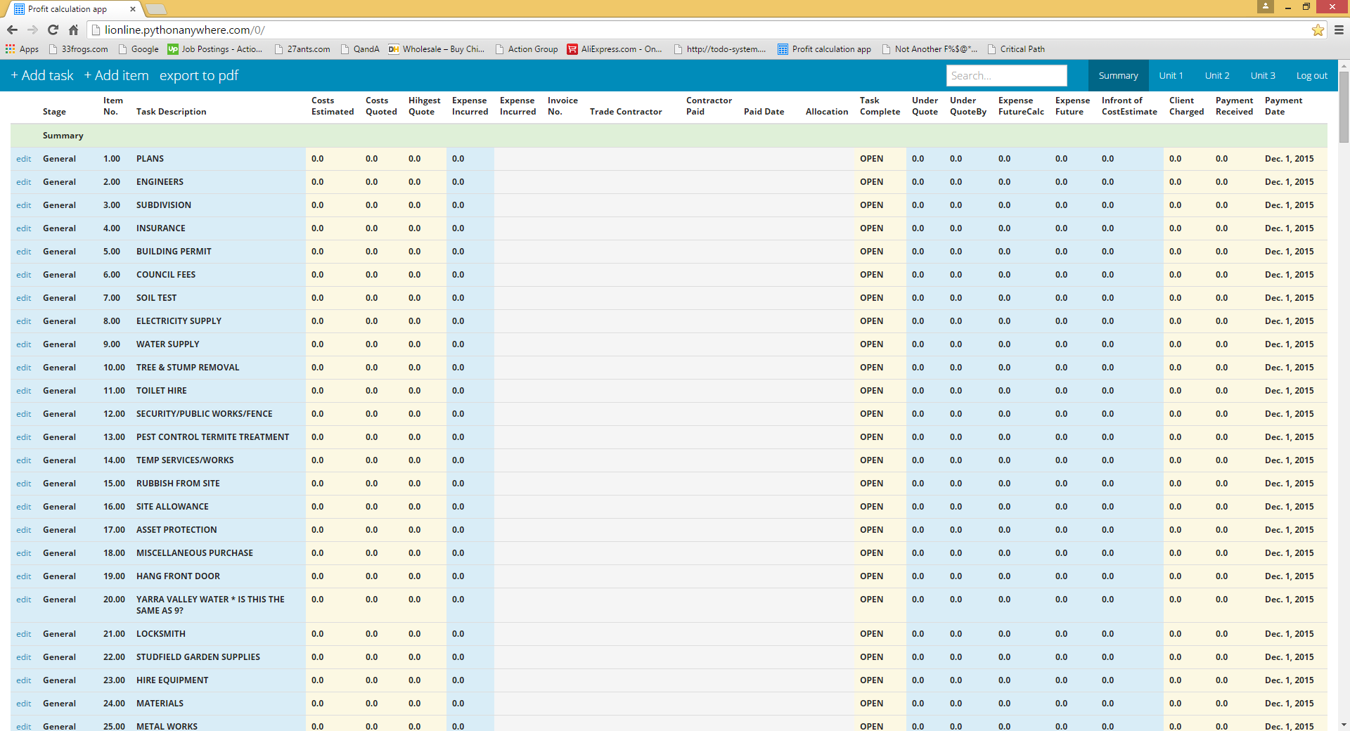When you scroll down we would like the headings to remain at the top of the page. This will allow the columns to be identified.

Need Headings to stay as above

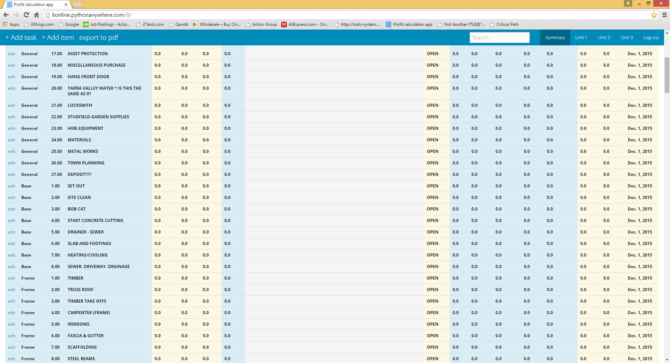

**Phone View:**

* When Michael opens this program on his phone could he only see the following columns-
  + Task description
  + Cost estimated
  + Expense incurred
  + Infront of cost estimate



**Inputting data into the cost estimated column:**

* We would like to be able to put numbers into the ‘cost estimated’ column by clicking on the screen without going into the ‘edit’ button.
* This should only be allowed for the cost estimated column.
* When you press the ‘tab’ button it should move to the row underneath allowing the ‘cost estimate’ to be inserted for the next task.

**Allocation Column:**

Press tab to move to the next figure , please ☺☺

Click here to insert a number, if possible ☺

* Can we please have the allocation column moved to the end of the page

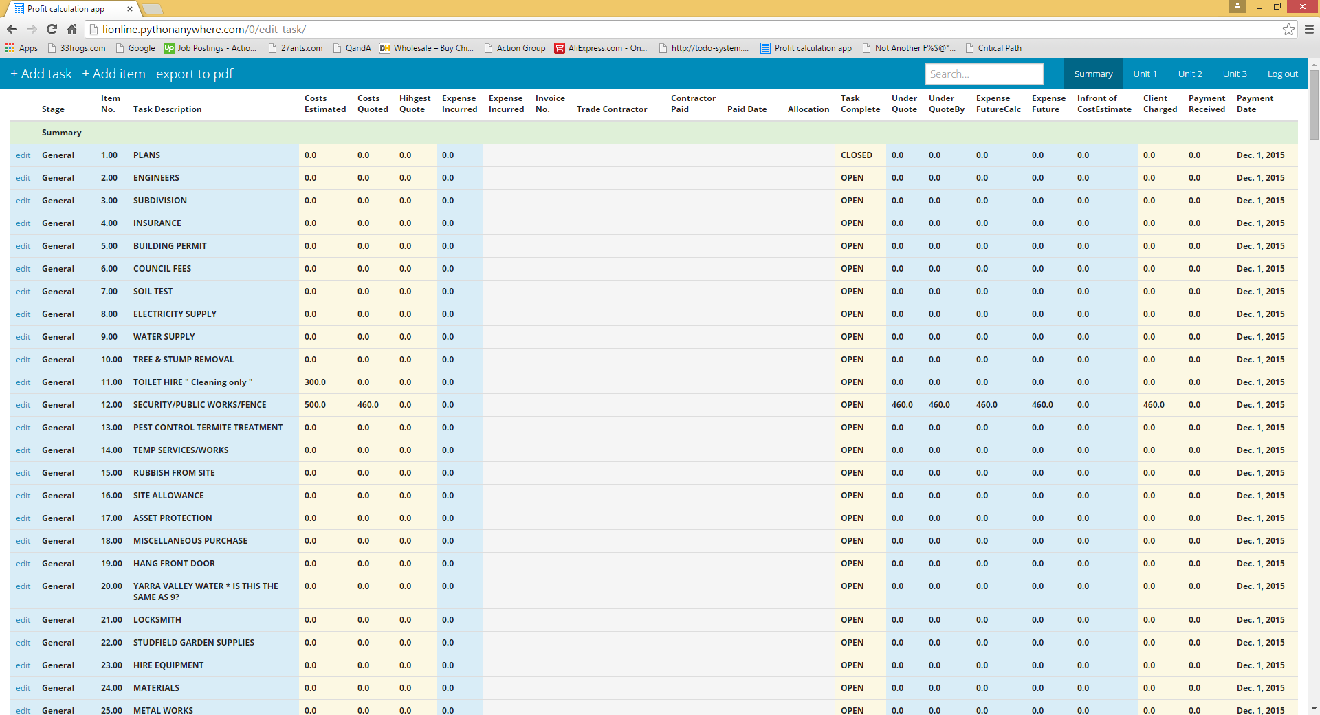

Allocation column moved here

**Alphabetical Order:**

* When you click on the ‘Task Description’ title could all tasks change into alphabetical order to make it easier to find a specific task.

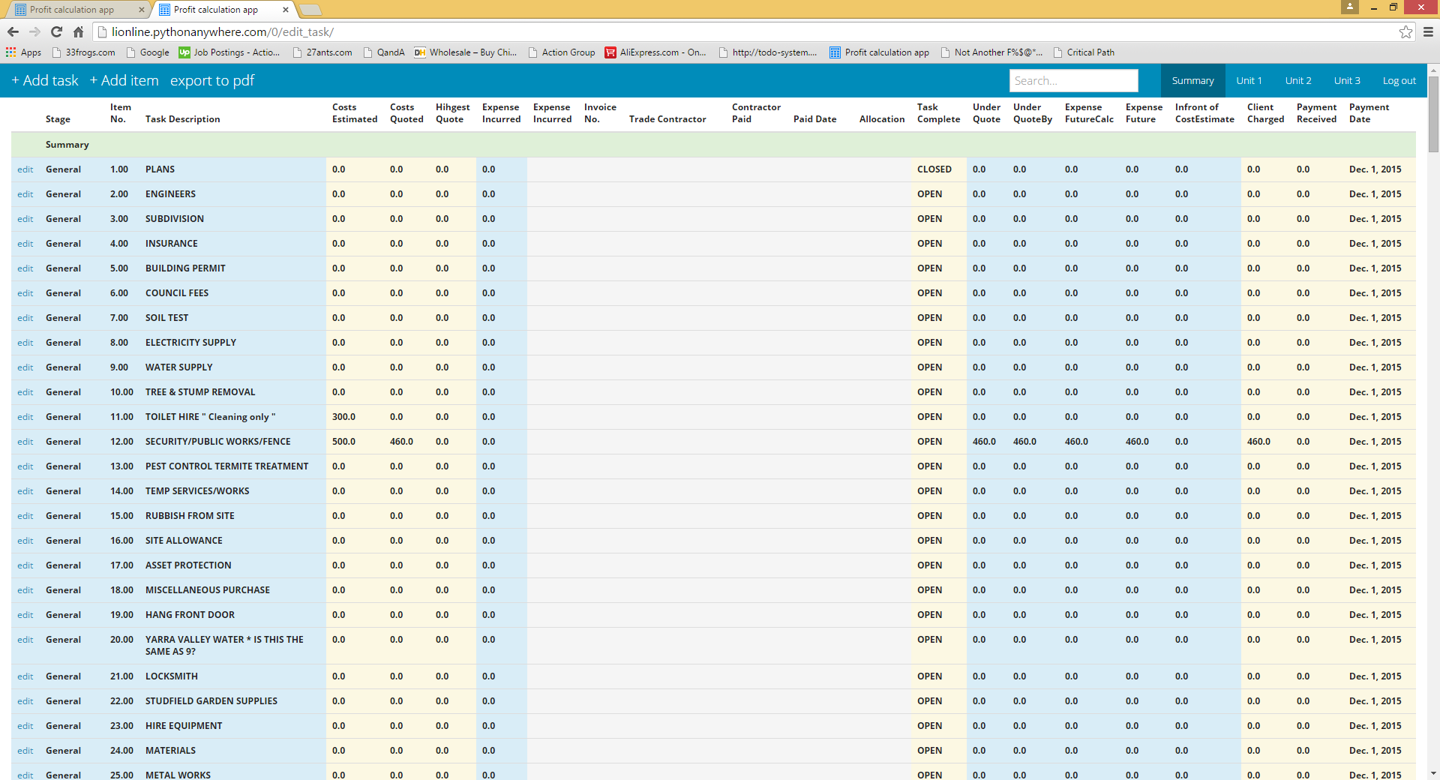

Click here and tasks change into alphabetical order, will help quick view ☺

**User permissions:**

* We would like to have 5 users
* Each user will be able to view specific things and will be authorised to modify certain figures
* The figures that these users can view is specified below

At the end of the table

New

|  |  |  |  |  |  |  |  |  |
| --- | --- | --- | --- | --- | --- | --- | --- | --- |
| User | Cost estimate | Edit  View | Cost Quoted | Edit  View | Highest | Expense Incurred | Invoice no. | Allocated |
| Michael | X C | C | X |  |  | X |  | C X |
| Tayla | X C | C | X |  |  | X |  | O |
| Amanda | X C | C | X |  |  | X |  | O |
| Maria | X |  | C | C |  | C | C | X |
| Tracy | X |  | C | C |  | C | C | O |

Only Michael and Maria can see this column

* Code-
  + Users with an X beside their name can view the information
  + Users with C can change the information
  + Users with a O cannot view the information
  + All other columns can be viewed by everyone
* Cost Estimate and cost quoted should have an ‘edit’ and ‘view’ button allowing them to be manipulated on screen without opening the ‘Add task’ button

**Job page changes:**

* On this page you should be able to change the Cost Estimate figures by double clipping the figure
* This allows the cost estimate figures to be changed quickly without pressing the ‘edit’ button

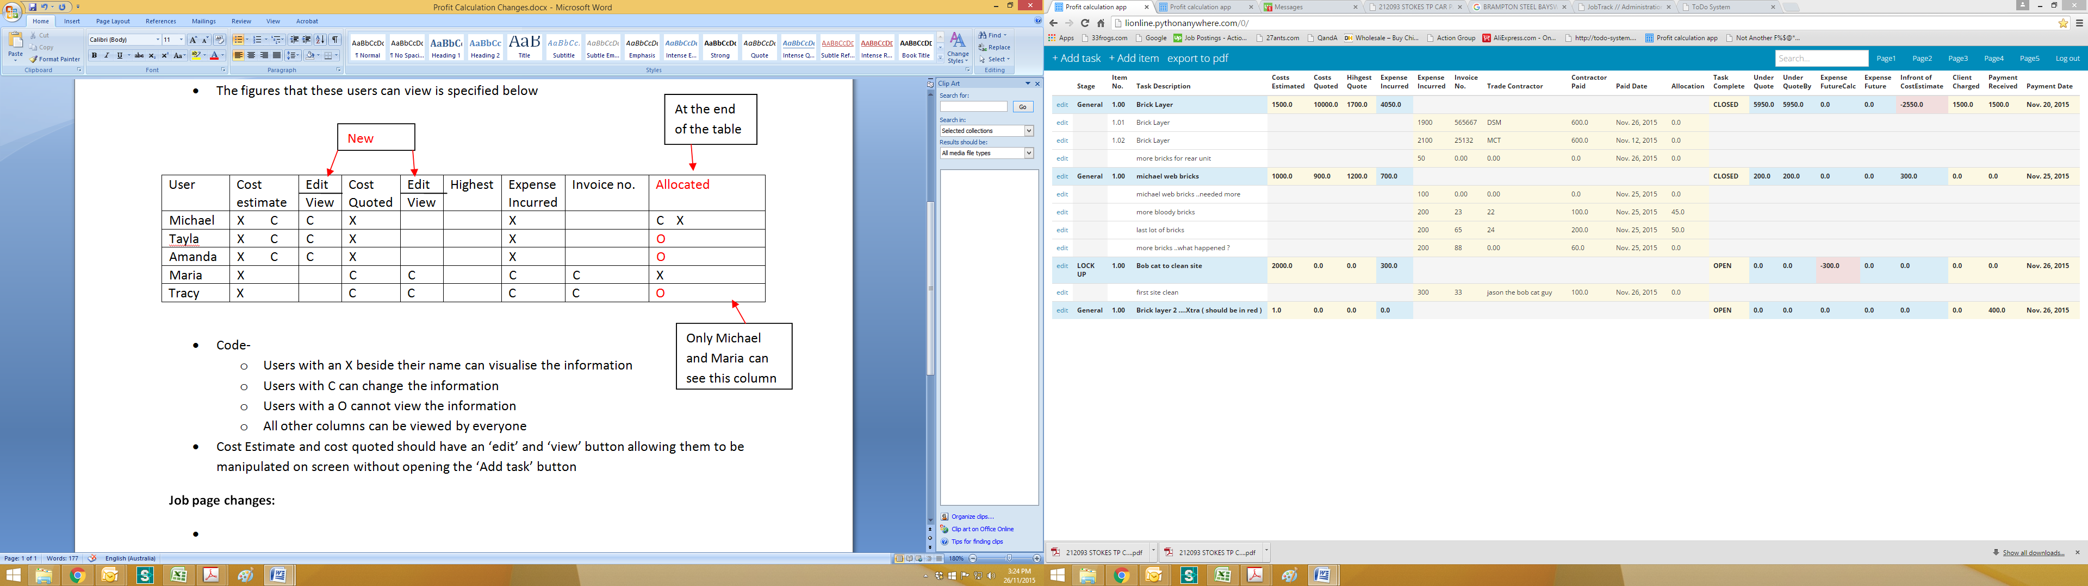

* When you press tab you should also be able to move down the column to the next entry

**Manipulations to the ‘add task’ options:**

* Change the title to ‘add task/ Estimate’
* Only 3 options should be available. These include
  + Stage
  + Task name
  + Cost estimate

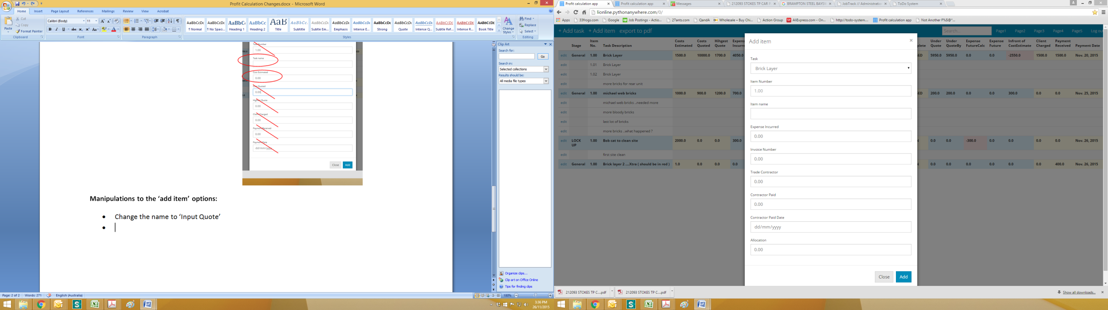 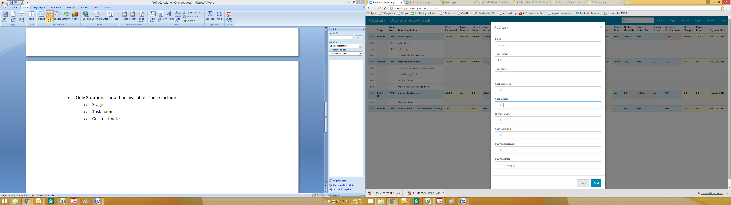

**Manipulations to the ‘add item’ options: done by the user Amanda**

* Change the name to ‘Input Quote’
* Only 3 options should be available. These include-
  + Task name (should be able to search)
  + Item name
  + Cost quoted
    - 0.00 should not be in this bar, it should be blank before entry , instead of having to backspace the 0.00 out.
* **‘Cost quoted’ option🡪** 
  + It should allow multiple quotes to be inserted
  + Each quote should have a box next to it
  + when the box is checked it means that is the quote that has been accepted
  + This can be done by users Michael, Tayla, Amanda and Maria
  + These quotes can be visualised on the home screen by holding your cursor over the ‘Highest quote’ figure.

**Input expenses option:**

* Like the ‘add item’ button an option called ‘**Input Expense’** should be next to the ‘add item’ button
* This is only for the users Tracy and Maria
* This should include-
  + Expense incurred
  + Invoice Number
  + Trade contractor
  + Contractor paid
  + Date....(insert or default)

**RULE:**

* Once a task is CLOSED you CANNOT add another expense or manipulate the figures
* When a job is closed only the users TRACY and MARIA can modify or add an expense
  + This new task should be titled as ‘Xtra’ and should be highlighted RED , see Michaels example “ Bricklayer Xtra “
  + This red item can only be changed by the user MICHAEL
  + All columns should be zero such as ‘cost estimated’ ‘cost quoted’ etc. Except for ‘expense incurred’ which is red

**Allocation option:**

* This option is only allowed to be used by the user MICHAEL.
* It can also be visualised by the user MARIA
* It should be situated next to the ‘Add Item’ option
* It should include the titles-
  + Allocated amount
  + Allocated item/ service
* These values should be totalled at the top of each unit sheet, and can be shown at the front home page, but only visible to Michael and Maria

**Deleting unnecessary columns:**

* Please DELETE these columns-
  + Expense incurred

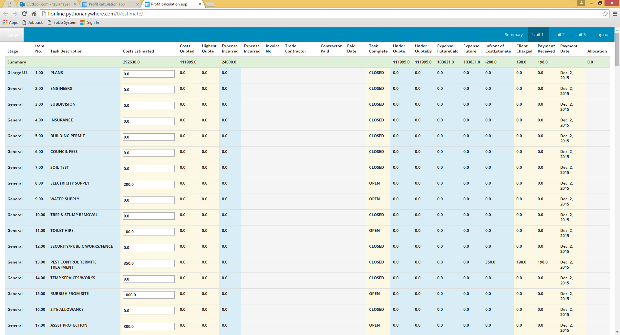

**Modifications to the existing columns:**

* Please change the ‘client charged’ column to ‘Charged’

**Inputting values:**

* The values in each column are not changing to show the profit gained so here is an example of how the profit calculator should function-
* Eg. Contract is priced at $300,000 but we estimate the cost to be $250,00 which leave $50,000 profit for us but this can change depending on the costs of all services

|  |  |  |  |  |  |
| --- | --- | --- | --- | --- | --- |
| **Task** | **Cost Estimated** | **Lowest Quote** | **Highest Quote** | **Expense Incurred** | **Infront of Cost Estimate** |
| **Plumbing** | **$1000** | **1200** | **1500** | **1270** | **-$270** |
|  | This is a number we estimate and put aside for this specific task | This is the quote we use |  | An extra $70 was charged on top of the $1200 | So we have exceeded our estimated cost of $1000 by $270 which means we loose $270 from the $50,000 profit |
| **Electrical** | **$2000** | **1500** | **2500** | **1600** | **+ $400** |
|  |  |  |  |  | We only spent $1600 of the designated $2000 which means we make a profit of $400 |

* Where the ‘Infront of cost estimate’ column is a negative number meaning we have lost money the values should appear **RED in colour**

**Total Profit:**

* The total profit value will always be changing depending on the profit gained and lost.
* Therefore, this value needs to automatically change depending on ‘infront of cost Estimate’ values
* Eg. We started with an estimate of $50,000 profit but we lost $270 and then gained $400

|  |  |
| --- | --- |
| **Profit-** | **Infront of cost estimate** |
| **$50,000** | -$270 |
| **$49,730** | +$400 |
| **$50,130** |  |

* Notice how this number is always changing in relation to the ‘infront of cost estimate’ column
* These columns need to interact to generate this ‘profit’ value
* This total profit should appear on the summary page so we can always keep track to this value

**Option to create new stage:**

* There should be a column dedicated to ‘Extras/ variations’ which should be at the bottom of the list of tasks
* These extras generate a profit aswell
* Eg. Our client requires extra windows which we haven’t accounted for

|  |  |  |
| --- | --- | --- |
| **Cost quoted** | **Client Charged** | **Infront of cost estimate** |
| **$5000** | **$6000** | **+$1000** |
| It will cost our client an extra $5000 to install extra windows | Instead we charge an extra $1000 | This means that we have made $1000 profit which gets added to the total profit value |

**I HOPE THESE EXAMPLES HAVE HELPED YOU TO SEE HOW WE WOULD LIKE THE ‘INFRONT OF COST ESTIMATE’ COLUMN AND THE TOTAL PROFIT TO INTERACT**

**THIS ALLOWS US TO HAVE UP TO DATE VALUES AND TO KNOW AT ALL TIME WHAT OUR PROFIT IS AND WHETHER WE ARE LOOSING MONEY ON A JOB. THEREFORE, IT IS CRUCIAL THAT THESE VALUES ARE RECENT.**

**Other minor changes:**

* Once you have finished adding an item under a task could you please remain at that task that you were modifying instead of always returning to the top of the page.
* We have found it is very time consuming when you add an item and then have to scroll back down the page and find where you are at again

**Inputting Cost estimate:**

* Can we please create an ‘Enter cost Estimate’ button next to the summary button at the top of the page which allows you to input the ‘cost estimate’ values instead of having the input bars always present.

Please put the ‘Enter Cost Estimate’ button here

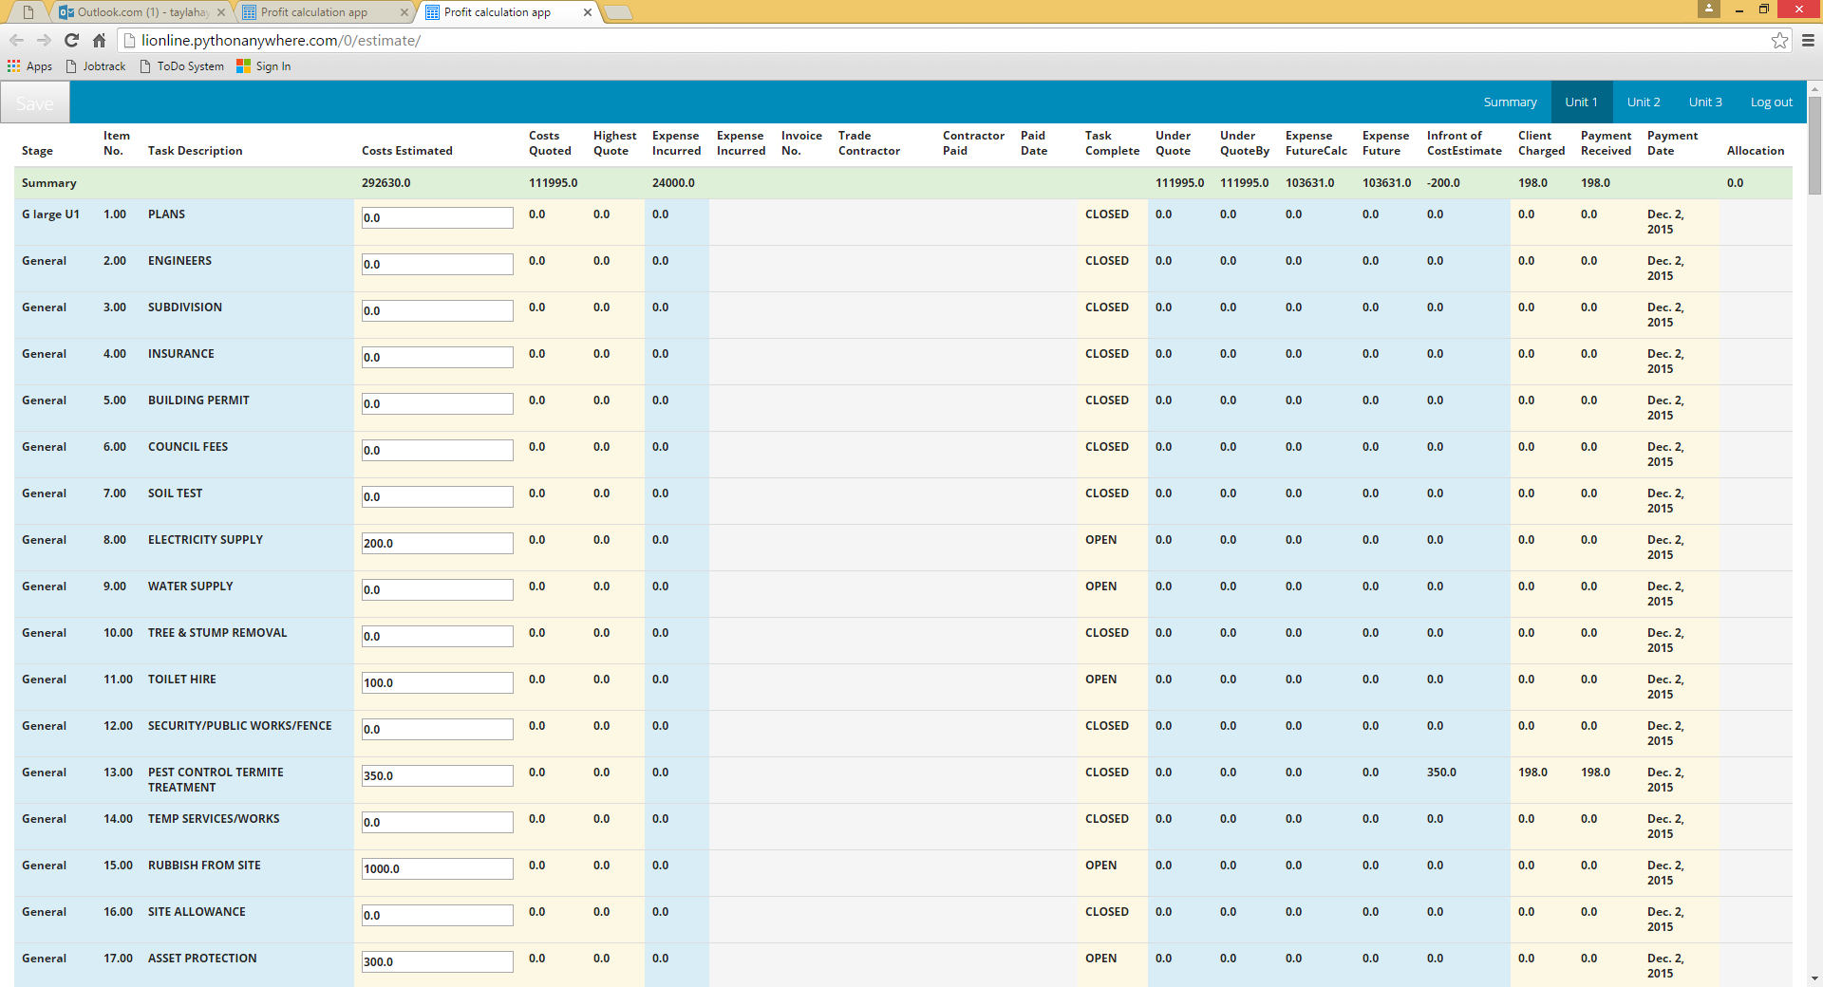

These boxes only appear when you press ‘Enter Cost Estimate’ button